Bank Loan SQL Queries
Bank Loan Report/Summary
KPI’s
-- Total Loan application
SELECT COUNT(id) AS Total_Loan_Application From bank_loan
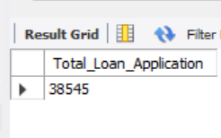
-- MTD Loan Application
SELECT COUNT(id) AS Total_Application FROM bank_loan
WHERE MONTH(issue_date)=12
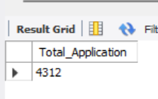
-- PMTD Loan Applications
SELECT COUNT(id) AS PMTD_Total_Applications FROM bank_loan
WHERE MONTH(issue_date) = 11
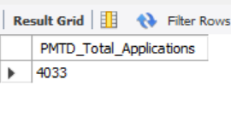
-- Total Funded Amount
SELECT SUM(loan_amount) AS Total_Funded_Amount FROM bank_loan
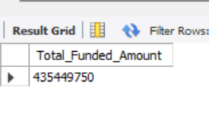
-- MTD Total Funded Amount
SELECT SUM(loan_amount) AS MTD_Total_Funded_AMOUNT FROM bank_loan
WHERE MONTH(issue_date)=12
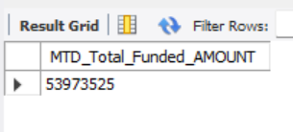
-- PMTD Total Funded Amount
SELECT SUM(loan_amount) AS PMTD_Total_Funded_AMOUNT FROM bank_loan
WHERE MONTH(issue_date)=11
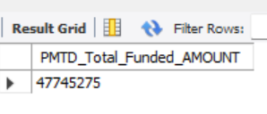
-- Total Amount Received
SELECT SUM(total_payment) AS Total_Amount_Collected FROM bank_loan
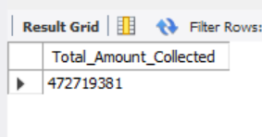
-- MTD Total Amount Received
SELECT SUM(total_payment) AS MTD_Total_Amount_Collected FROM bank_loan
WHERE MONTH(issue_date)=12
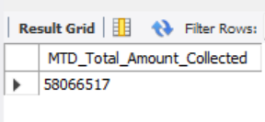
-- PMTD Total Amount Received
SELECT SUM(total_payment) AS PMTD_Total_Amount_Collected FROM bank_loan
WHERE MONTH(issue_date)=11
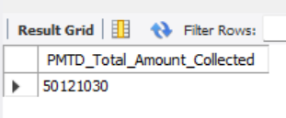
-- Average Interest Rate
SELECT AVG(int_rate)*100 AS Avg_Int_Rate FROM bank_loan
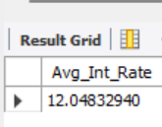
-- MTD Average Interest Rate
SELECT AVG(int_rate)*100 AS MTD_Avg_Int_Rate FROM bank_loan
WHERE MONTH(issue_date) = 12
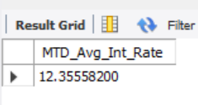
-- PMTD Average Interest Rate
SELECT AVG(int_rate)*100 AS PMTD_Avg_Int_Rate FROM bank_loan
WHERE MONTH(issue_date) = 11
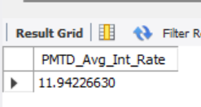
-- Avg DTI
SELECT AVG(dti)*100 AS Avg_DTI FROM bank_loan
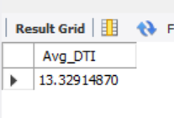
-- MTD Avg DTI
SELECT AVG(dti)*100 AS MTD_Avg_DTI FROM bank_loan
WHERE MONTH(issue_date) = 12
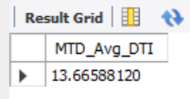
-- PMTD Avg DTI
SELECT AVG(dti)*100 AS PMTD_Avg_DTI FROM bank_loan
WHERE MONTH(issue_date) = 11
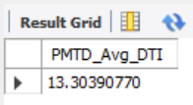
Good Loan Issued
-- Good Loan Percentage
SELECT
(COUNT(CASE WHEN loan_status = 'Fully Paid' OR loan_status = 'Current' THEN id END) * 100.0) /
COUNT(id) AS Good_Loan_Percentage
FROM bank_loan
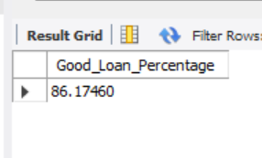
-- Good Loan Applications
SELECT COUNT(id) AS Good_Loan_Applications FROM bank_loan
WHERE loan_status = 'Fully Paid' OR loan_status = 'Current'
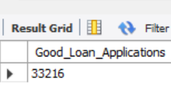
-- Good Loan Funded Amount
SELECT SUM(loan_amount) AS Good_Loan_Funded_amount FROM bank_loan
WHERE loan_status = 'Fully Paid' OR loan_status = 'Current'
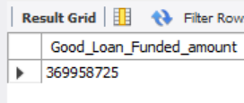
-- Good Loan Amount Received
SELECT SUM(total_payment) AS Good_Loan_amount_received FROM bank_loan
WHERE loan_status = 'Fully Paid' OR loan_status = 'Current'
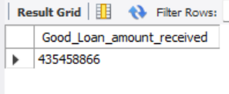
Bad Loan Issued
-- Bad Loan Percentage
SELECT
(COUNT(CASE WHEN loan_status = 'Charged Off' THEN id END) * 100.0) /
COUNT(id) AS Bad_Loan_Percentage
FROM bank_loan
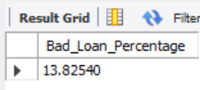
-- Bad Loan Applications
SELECT COUNT(id) AS Bad_Loan_Applications FROM bank_loan
WHERE loan_status = 'Charged Off'
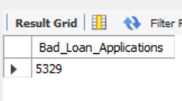
-- Bad Loan Funded Amount
SELECT SUM(loan_amount) AS Bad_Loan_Funded_amount FROM bank_loan
WHERE loan_status = 'Charged Off'
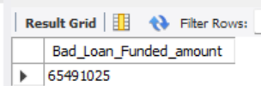
-- Bad Loan Amount Received
SELECT SUM(total_payment) AS Bad_Loan_amount_received FROM bank_loan
WHERE loan_status = 'Charged Off'
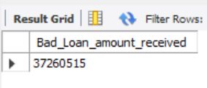

Loan Status
SELECT
loan_status,
COUNT(id) AS LoanCount,
SUM(total_payment) AS Total_Amount_Received,
SUM(loan_amount) AS Total_Funded_Amount,
AVG(int_rate * 100) AS Interest_Rate,
AVG(dti * 100) AS DTI
FROM
bank_loan
GROUP BY
loan_status
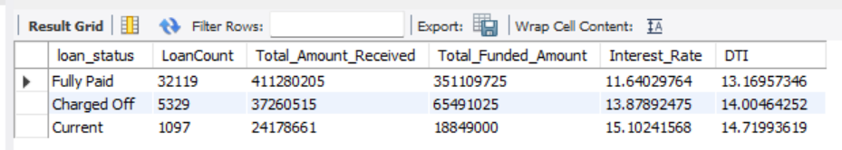
SELECT
loan_status,
SUM(total_payment) AS MTD_Total_Amount_Received,
SUM(loan_amount) AS MTD_Total_Funded_Amount
FROM bank_loan
WHERE MONTH(issue_date) = 12
GROUP BY loan_status
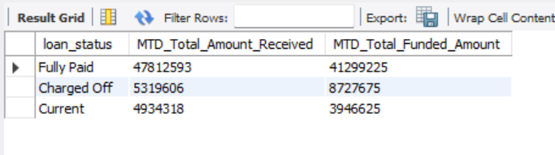
BANK LOAN REPORT | OVERVIEW
MONTH
SELECT
MONTH(issue_date) AS Month_Number,
MONTHNAME(issue_date) AS Month_Name,
COUNT(id) AS Total_Loan_Applications,
SUM(loan_amount) AS Total_Funded_Amount,
SUM(total_payment) AS Total_Amount_Received
FROM bank_loan
GROUP BY
MONTH(issue_date),
MONTHNAME(issue_date)
ORDER BY
Month_Number;
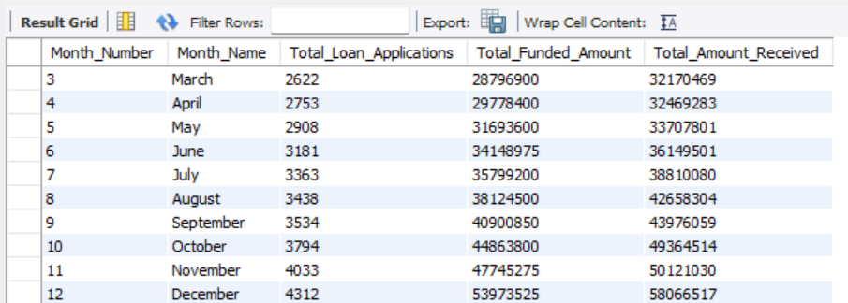
STATE
SELECT
address_state AS State,
COUNT(id) AS Total_Loan_Applications,
SUM(loan_amount) AS Total_Funded_Amount,
SUM(total_payment) AS Total_Amount_Received
FROM bank_loan
GROUP BY address_state
ORDER BY address_state
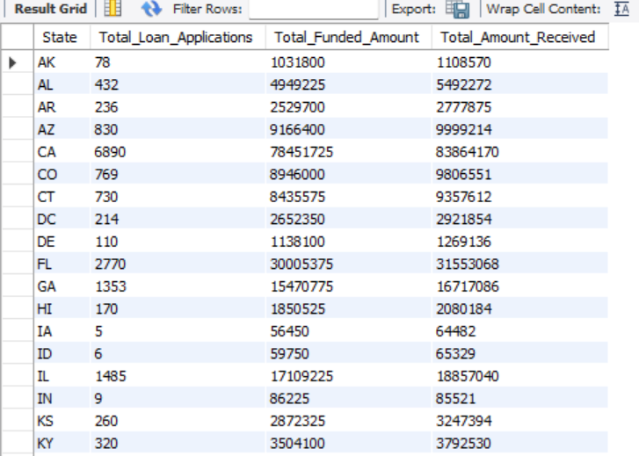
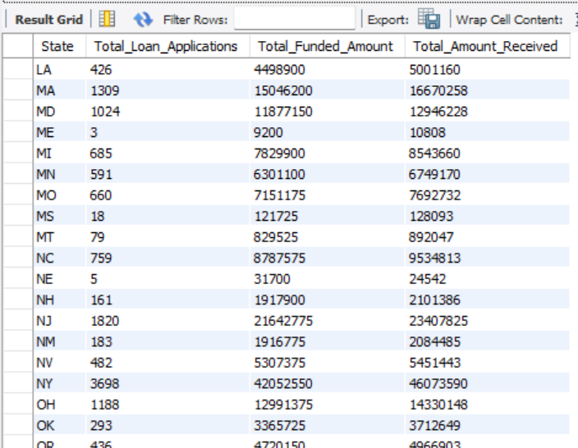
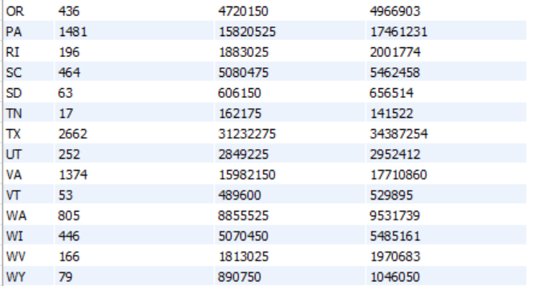
TERM
SELECT
term AS Term,
COUNT(id) AS Total_Loan_Applications,
SUM(loan_amount) AS Total_Funded_Amount,
SUM(total_payment) AS Total_Amount_Received
FROM bank_loan
GROUP BY term
ORDER BY term
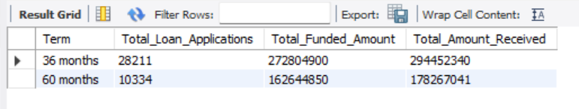
EMPLOYEE LENGTH
SELECT
emp_length AS Employee_Length,
COUNT(id) AS Total_Loan_Applications,
SUM(loan_amount) AS Total_Funded_Amount,
SUM(total_payment) AS Total_Amount_Received
FROM bank_loan
GROUP BY emp_length
ORDER BY emp_length
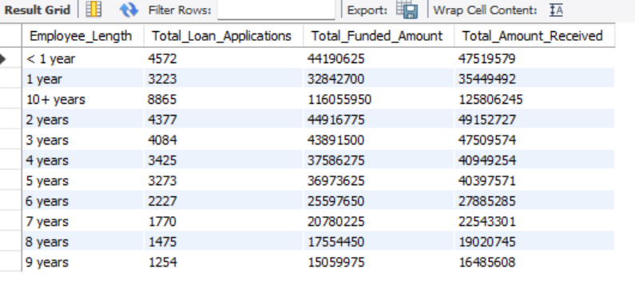
PURPOSE
SELECT
purpose AS PURPOSE,
COUNT(id) AS Total_Loan_Applications,
SUM(loan_amount) AS Total_Funded_Amount,
SUM(total_payment) AS Total_Amount_Received
FROM bank_loan
GROUP BY purpose
ORDER BY purpose
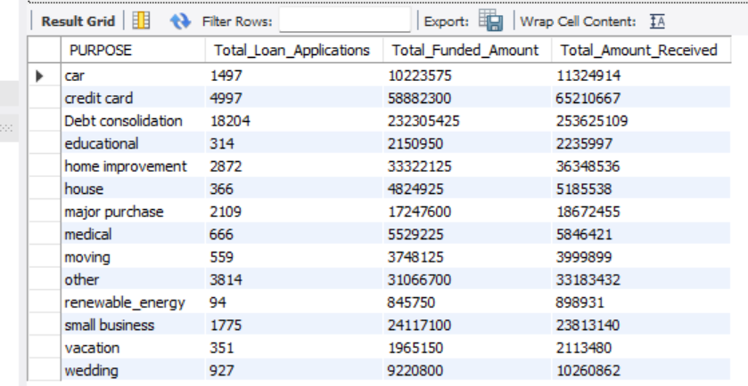
HOME OWNERSHIP
SELECT
home_ownership AS Home_Ownership,
COUNT(id) AS Total_Loan_Applications,
SUM(loan_amount) AS Total_Funded_Amount,
SUM(total_payment) AS Total_Amount_Received
FROM bank_loan_data
GROUP BY home_ownership
ORDER BY home_ownership
